
NAME: TAHA MOIZ ELECTRICWALA
ROLLNO: 26ITB002
COURSE CODE: 1CS501CC26
PRACTICAL NUMBER: 1

AIM: (A) Demonstration of CodeBlocks IDE. Make use of CodeBlocks to write and compile a simple C program (“Hello World”).
METHODOLOGY:
#include <stdio.h>

int main(){
printf("Hello World");
return 0;
}

INPUT/OUTPUT:
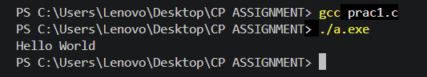
AIM: (B) Illustrate the use of scanf and printf function to read and display values of different types of variables, address of a variable in C language.
METHODOLOGY:
#include <stdio.h>

int main(){
int a;
char ch;
float fl;

printf("Enter your first number \n");
scanf("%d", &a);
printf("Your first number is %d\n", a);

printf("Enter a character \n");
scanf(" %c", &ch);
printf("Your character is %c \n", ch);

printf("Enter a decimal value\n");
scanf("%f", &fl);
printf("The entered value is %f\n", fl);

return 0;
}
INPUT/OUTPUT:
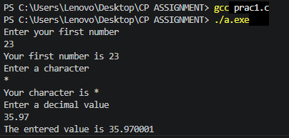
AIM: (C): Demonstrate different escape sequences.
METHODOLOGY:
#include <stdio.h>

int main(){
// \n prints the next statement in new line.
// \? prints a literal question mark in the output screen.
printf("My name is Taha \n whats your name\?");

// \" prints a literal double quote on output screen.
printf("He replied, \" Myself Aman\" \n");

// \t prints a tab on the output screen.
printf ("\tNice to meet you");

return 0;
}

INPUT/OUTPUT:
